University of Toledo
College of Business & Innovation
Web Casting Frequently Asked Questions (FAQ)

How do I watch and participate in a web cast?
Informative Web Cast on “How to Watch a Mediasite Presentation”
http://stpsls02.st.utoledo.edu/mediasite/Viewer/?peid=25086ff89193443c84b32e834c7417fb

How do I submit questions?
Submit questions live during the event or later on-demand by clicking on the Ask a Question button 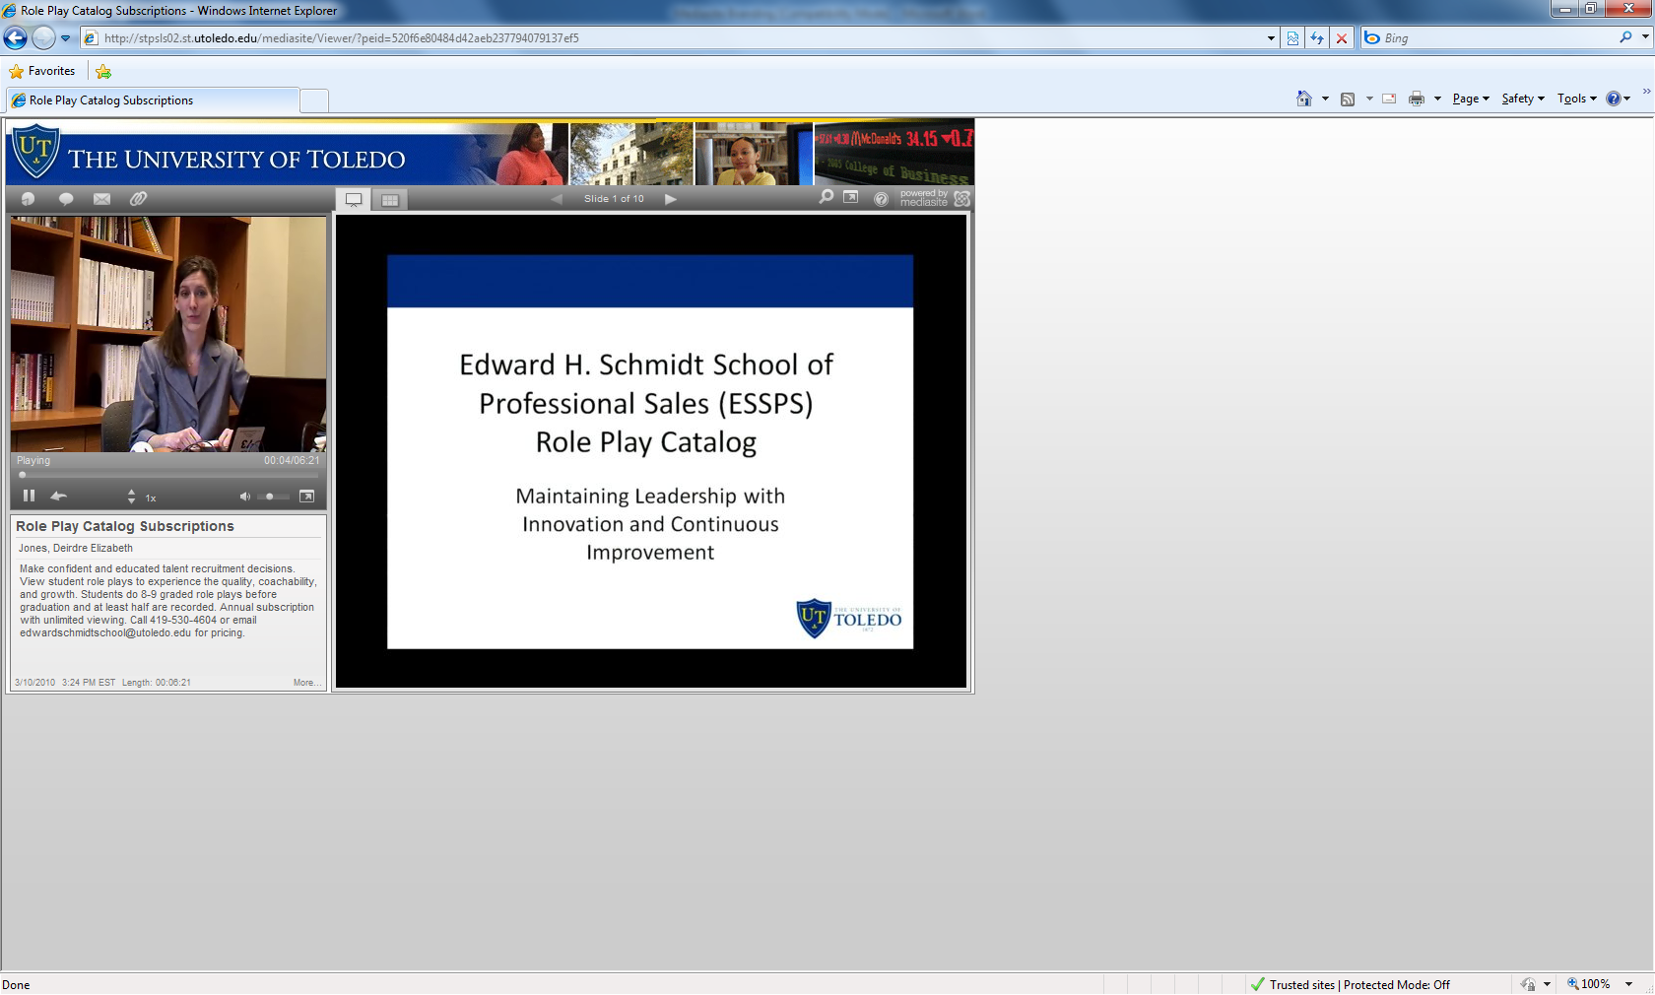

How do I access the event web casts?
Event web casts can be accessed directly or through a COBI center’s event catalog (just click and watch). COBI centers include the Center for Family & Privately-Held Business, the Edward H. Schmidt School of Professional Sales (ESSPS), and the Executive Center for Global Competitiveness (ECGC). COBI centers provide links to their catalogs and events on their websites. To help you find what you need, catalogs have a search and content can be sorted. For live events, the event link is sent in advance via email to registered participants. Some events are secured with a login that comes with event registration or through center memberships/partnerships.

Do I need to download any software to watch the web casts?
No. The COBI uses Sonic Foundry’s Mediasite platform for web casting and knowledge management. The Mediasite Viewer runs on major internet browsers such as Internet Explorer, Firefox, Safari, and Chrome.

What kind of an internet connection do I need to watch the web casts?
To view the rich media web cast that has video, audio, and media (slides, computer screens, etc), a high speed internet connection such as a cable modem, DSL, or T1 is needed.

What will my screen look like?

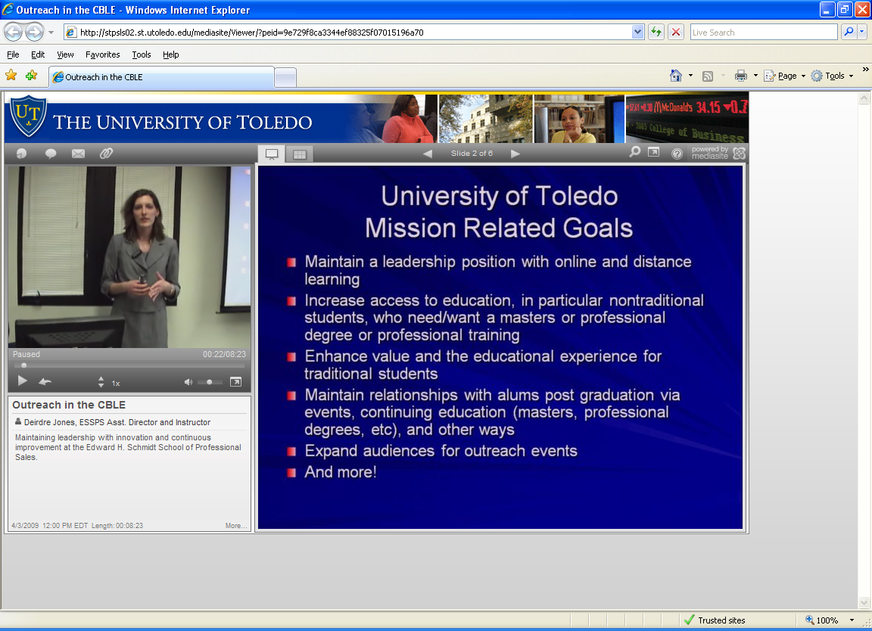

What makes the web casts interactive?
There are 3 things embedded in the Mediasite Viewer that make COBI event web casts interactive:
- Presentation links – links to other helpful websites such as a calendar of events, event registrations, information flyers, other presentations, etc.
- Ask a Question – sends questions and comments in real time to the event’s designated contact or team of people. Questions can be submitted at any time – even during a live web cast!
- Polls – provide feedback or insight on topics by answering multiple choice questions. Results are completely anonymous and are reported as an aggregate.

What is the difference between a live web cast and an on-demand web cast?
A live web cast is a real time, secure internet stream of an event. The live stream has a 5-10 second delay.

An on-demand web cast is the same event as the live presentation and is available to securely watch 24*7. On-demand presentations will be archived and available as long as the content is still relevant and has suitable viewing traffic.

How long after a live web cast has ended will I have to wait to watch the on-demand web cast?
Wait times will vary depending on how long the live broadcast is. In many cases, the wait will be seconds, but it could be a few minutes for longer events. In some cases, editing may need to take place prior to releasing the on-demand web cast and will be communicated prior to or during the live web cast.

I have a hard time viewing things on my computer screen and often need to enlarge things. Can I still enjoy a web cast?
Yes! You can take the video window and the media/image window full screen . There is also a magnifier you control with your mouse that you can use to enlarge the media/images.

Can I get a podcast of the events?
Pod casting will be rolled out in the future.

Are the COBI’s web casting and other facilities available to rent by outside organizations?
Yes. Save time, money, and improve internal coordination with secure, interactive web casts for your own organization’s training, events, role play assessments, meetings, etc. Facility rentals in the Savage & Associates Complex for Business Learning and Engagement including portable equipment and video conferencing are available. Call 419-530-2978 for more information.

